Peace

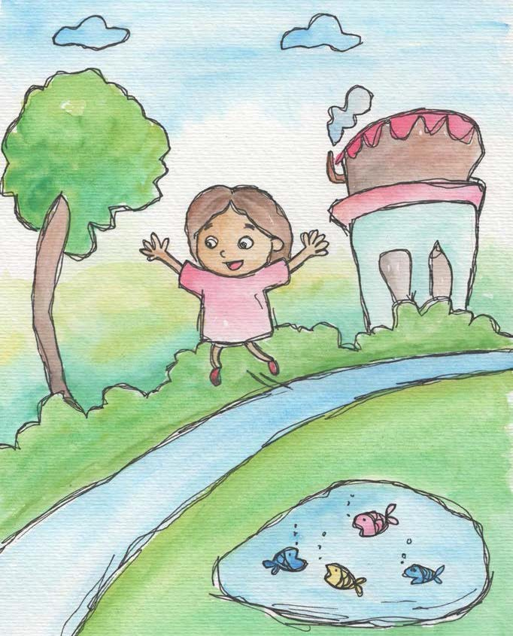

♦Peace is being quiet inside.

♦Peace is having good feelings inside.

♦Peace is feeling relaxed and safe.

♦Peace is when people get along and don’t argue or hit.
♦Peace is having positive thoughts for myself and others.
♦Peace begins within each one of us.

From Living Values Education Activities for Children Ages 3-7 years © 2019 Association for Living Values Education International - www.livingvalues.net

