Respect

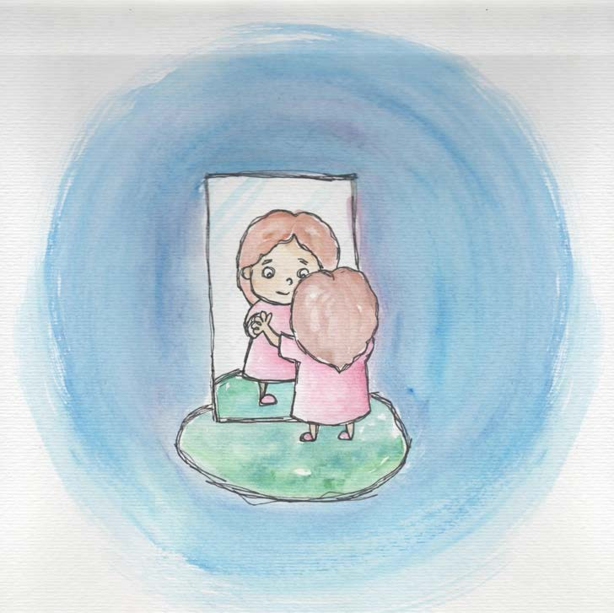
♦Respect is feeling good about myself.

♦Respect is knowing I am unique and valuable.

♦Respect is valuing myself.

♦Respect is knowing I am lovable and capable.

♦Respect is liking who I am.

♦Respect is taking care of myself.

♦Respect is listening to others.

♦Respect is knowing others are valuable, too.

♦Respect is treating others nicely.

From Living Values Education Activities for Children Ages 3-7 years © 2019 Association for Living Values Education International - www.livingvalues.net

