Simplicity
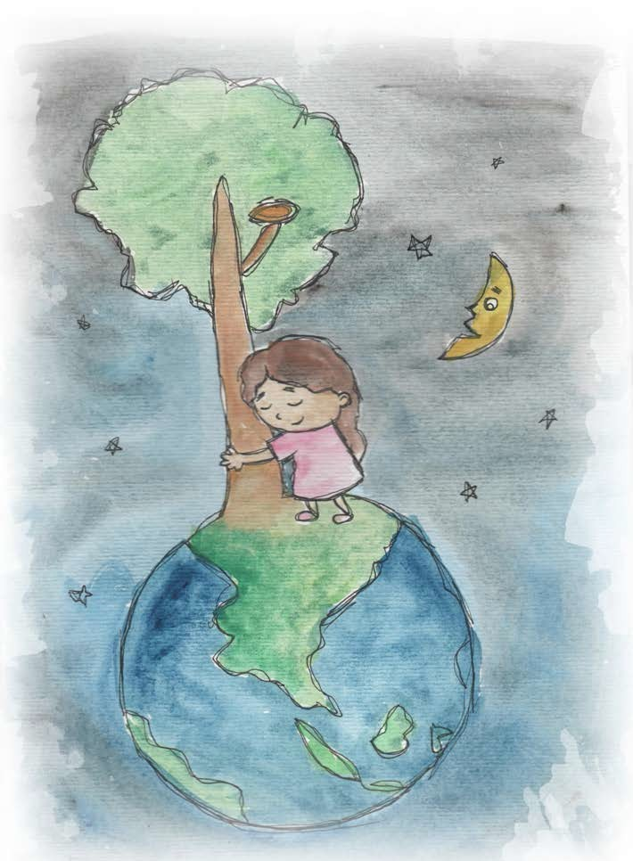

  - Simplicity is enjoying simple things.
  - Simplicity is beautiful and natural.

- Simplicity is using what we already have.

  - Simplicity is learning from the earth.

- Caring for Our Earth and Her Oceans is important.
- Our Earth is our home and the home of animals.

  - Nature is beautiful.


From Living Values Education Activities for Children Ages 3-7 years © 2019 Association for Living Values Education International -www.livingvalues.net

