Honesty

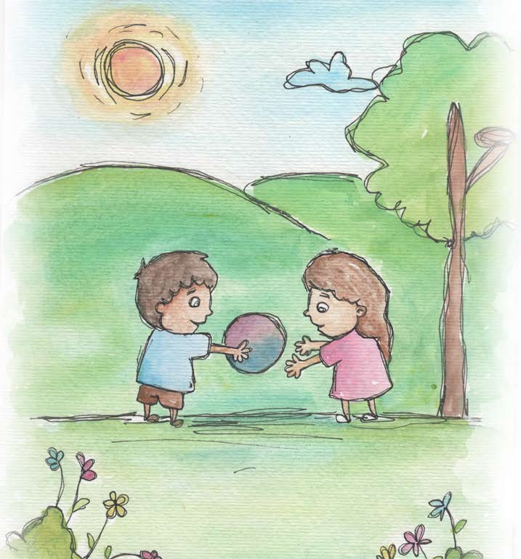

- Honesty is telling what really happened.
- Honesty is telling the truth.
- Honesty is when you don’t tell a lie, you don’t cheat.
- Honesty is keeping your promises.
- When I feel honest, I feel clear inside.
- When I am honest, I can learn and help others learn
to be giving.
- The heart of honesty is fairness.
- Honesty creates trust.

From Living Values Education Activities Children Ages 8-14 years © 2019
Association for Living Values Education International - www.livingvalues.net

