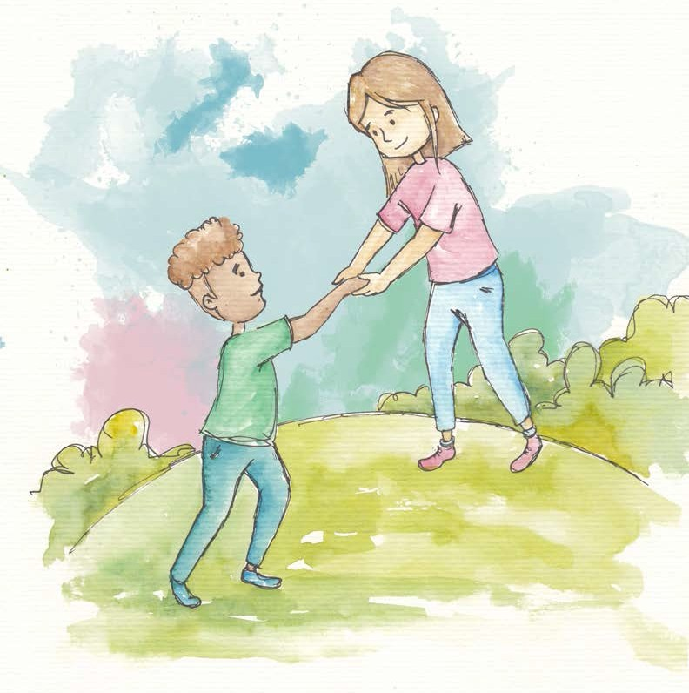
Humility
Humility is staying light and easy inside. Humility goes together with self-respect.

Humility is when I know my strengths but don’t brag or show off.

Humility makes arrogance disappear. A humble person can stay happy inside while listening to others.

With the balance of self-respect and humility,
I can stay powerful inside and
not need to control others around me.

Humility allows one to be great in the hearts of many. Humility creates an open mind.

With humility I can recognize my own strengths and the strengths of others


From Living Values Education Activities for Children Ages 8-14 years © 2019
Association for Living Values Education International - www.livingvalues.net

