Simplicity
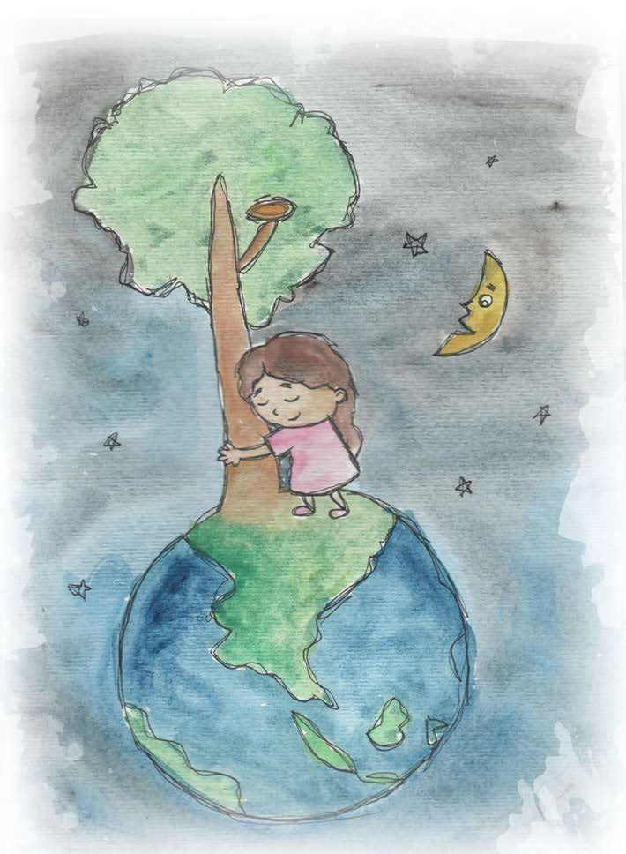

- Simplicity is enjoying simple things.
- Simplicity is beautiful and natural.
- Simplicity is using what we already have.
- Simplicity is learning from the earth.
- Caring for Our Earth and Her Oceans is important.
- Our Earth is our home and the home of animals.
- Nature is beautiful.

From Living Values Education Activities for Children Ages 8-14 years © 2019
Association for Living Values Education International - www.livingvalues.net

