Cooperation
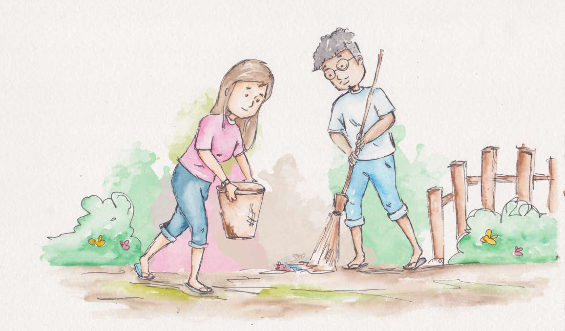
Cooperation exists when people work together toward
a common goal.

One who cooperates creates good wishes and pure feelings
for others and the task.

When cooperating, there is a need to know what is needed.

Sometimes an idea is needed, sometimes we need to let go of our idea. Sometimes we need to lead and sometimes we need to follow.

Cooperation is governed by the principle of mutual respect.

One who cooperates receives cooperation.

Where there is love, there is cooperation.

By staying aware of my values, I can give cooperation.
Courage, consideration, caring and sharing provide a foundation for cooperation.
From Living Values Education Activities for Young Adults © 2019 Association for Living Values Education International - www.livingvalues.net

