
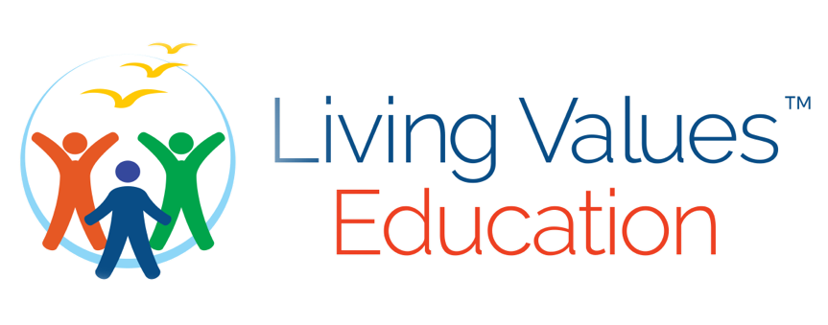

~
Discover the truth about your life

as it is now
with Honesty, Humility and Acceptance – take the Living Values 15min QUIZ
~

Values are about bringing your life into harmony and balance.
If you wish to further expand your Values Awareness, engage in the FREE
‘Living Values Education Self Reflection’ 12 week Course.

It is available via download from our website.

Email: distance@livingvalues.net – Web: www.livingvalues.net/distance
© 2021 Association for Living Values Education International

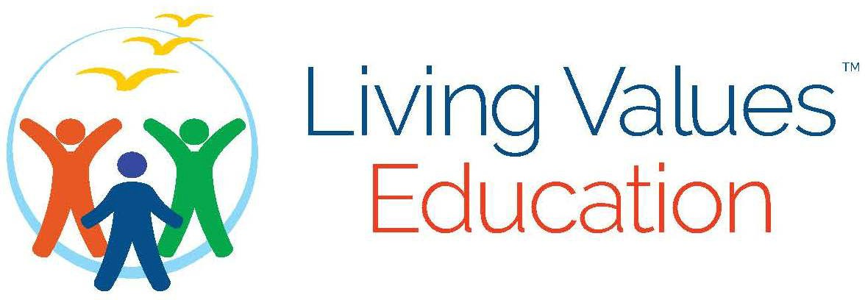

Why Would I Want to Develop

My Values?

Introducing the LVE 15-Quiz

If I had the desire to make a difference in the world, or, if I had the desire
to make my own life more peaceful, where would I start?
No matter what role we are currently playing, whether it be child in a family, parent, person in business, employee, school teacher, government official, retiree, whatever age, gender, nationality, spiritual belief, we all have one thing in common; a human requirement to meet our basic needs – to be Safe, Respected, Understood, Loved, Valued.
We deserve all those qualities in our life. Are they fully present now?
- Is my life perfect?
- Am I happy?
- Do I have what I want?
- Are my all my relationships in harmony? (Include my environment)
If your answer to these simple yet important questions is “Yes,” then you are a very special and unusual being because most of us believe we are lacking in many ways.
Could it be better? Perhaps it comes down to happiness. If I am happy, usually, my world reflects my own state of being through the circumstances I exist within and which are presented to me.
If there are areas of our lives that could improve, is there something I can do to make that happen? Of course, the answer is “Yes.” At some point in my life, I must recognise that I am not a victim of my circumstance, that I am responsible for my circumstance, and that only I can be the one to change that.
It starts with asking myself, “What do I value?” and “What are my values?” for my values guide my life.
Values lie deep in our psyche; they reflect our past experiences starting from childhood and, as such, create the foundation for our lifetime of behavior and our response to the world and people around us.
The only way to engage and enhance our values is through introspection and reflection; it can be challenging to see ourselves as we are. We cannot be taught values, yet they can be introduced and brought to our greater consciousness through activities encouraging self-realization, which is why Living Value's unique methodology of activities structured to meet different age groups and circumstances works so well.
Whose Values? It has been determined that there are fundamental values widely shared by all Humanity. Certainly not limited but for the purpose of our discovery these primary values form the core to lead us ever deeper into to determining our behaviour, relationship and our interaction at all levels of life.
Peace, Love and Caring, Respect, Responsibility, Tolerance, Honesty,
Humility, Happiness, Cooperation, Simplicity, Freedom and Unity.
Our relationship to these values and the degree to which we live through
them determine our lives, what we attract, and what we present to the world.
Awareness and interaction bring our values to the surface. By casting greater light on each value, we explore and encourage its positive dynamic to expand within us. We begin to live within a Values-based Atmosphere, and this changes Everything.
The benefit, then, is deep and personal. Whether we are children or grown adults, at any age, you can determine your future if your values are sound and active and expressed in your life. Living Values Education is all about developing Awareness of our Values and providing the understanding of how to live in a better world of our own creation.
Where to start: Take the 15-minute Quiz…


How to play

- Look at each question – one for each of the Values, consider carefully, not just the first thought that comes to you but how it might relate to several aspects of your life – your family, primary relationship, your kids, friends, the community, your environment. Go as deep as you can.

- Write whatever you feel is how the value relates to your life NOW, right now. As much as you like. This about your own behavior, your actions, your treatment of others and of yourself.

- Now consider the score you would give it based on 1-7, one being the lowest score and closest to the centre, and 7 being the highest score and the furthest out. Your score will relate to how much you are living in each value every day.

- Use the circle below and write your score in the segment of each Value.

- Total your score – the highest, or greatest potential would be 84 – the widest circle. Whatever your personal score is where you are now living in those values. Consider the implications if your life had a higher score, or what it might be like if it was lower.

- Start with Peace and mark the six dots on the right spoke of each segment from the centre to the outer wheel and write your score/number in the segment for each Value.

- Join the dots. This is then is the shape of the ‘wheel of your life’ as it is right now, by your own evaluation. What do you see? Is it balanced?

- Imagine your inner wheel to be the front wheel of your bicycle, how do think your ride would be? Smooth or bumpy? Is this something that could be better? Do you want to change this?

- To create change to have your life more rounded, more balanced, enhanced… focus on the values with the lowest score and you can see easily from your answers what has to change in you to bring greater awareness to each aspect of your life.

REMEMBER, there is no judgment about yourself - only recognition and awareness.

Living Values Quiz

Look at each of the Values below, ask yourself honestly, ‘how does my life score in this question?’ Write your answer with a score of 1 to 7.
For example: always=7, sometimes=5, seldom=3, never= 1.

  - Peace: ( )
Do I create a peaceful atmosphere in my home and my work?

  - Love: ( )
Do I express my love toward myself and others, is my love unconditional?

  - Respect: ( )
Do I honour the worth of others and myself in my daily interactions?

  - Tolerance: ( )
Can I be tolerant of others or circumstances in every moment?

Responsibility: ( )
Do I take personal responsibility when things go wrong?

  - Honesty: ( )
Am I willing to be honest even though I may be adversely affected by the outcome?
  - Humility: ( )
Can I forgive someone who has hurt me?

  - Happiness͗: ( )
Do I feel really happy in my life all the time?

Cooperation: ( )
Can I accept help from others, whether I want it or not?

Simplicity: ( )
Do I keep my life simple?

  - Freedom: ( )
Do I feel free to make another choice in my relationships, in my work, in my life?

  - Unity: ( )
Am I feeling connected to life, my environment and to those around me?

My Wheel of My Life Today
Am I living in my values? Here is an easy way to discover where we are at any moment. Join the dots of these twelve core values. From YOUR OWN score of 1 - 7, with one being the lowest and closest to the center and seven being the highest and furthest out, place your score - the degree that each Value is FULLY present within you now - at this moment in your life. Please start with PEACE.

Add the twelve numbers together—the greatest expression of LIVING VALUES you could have would be 84 (the outer circle where the angels live!). Whatever you have is where you are now in your life. Using your own honest reflection will enable you to refocus on those Values with the lowest score.

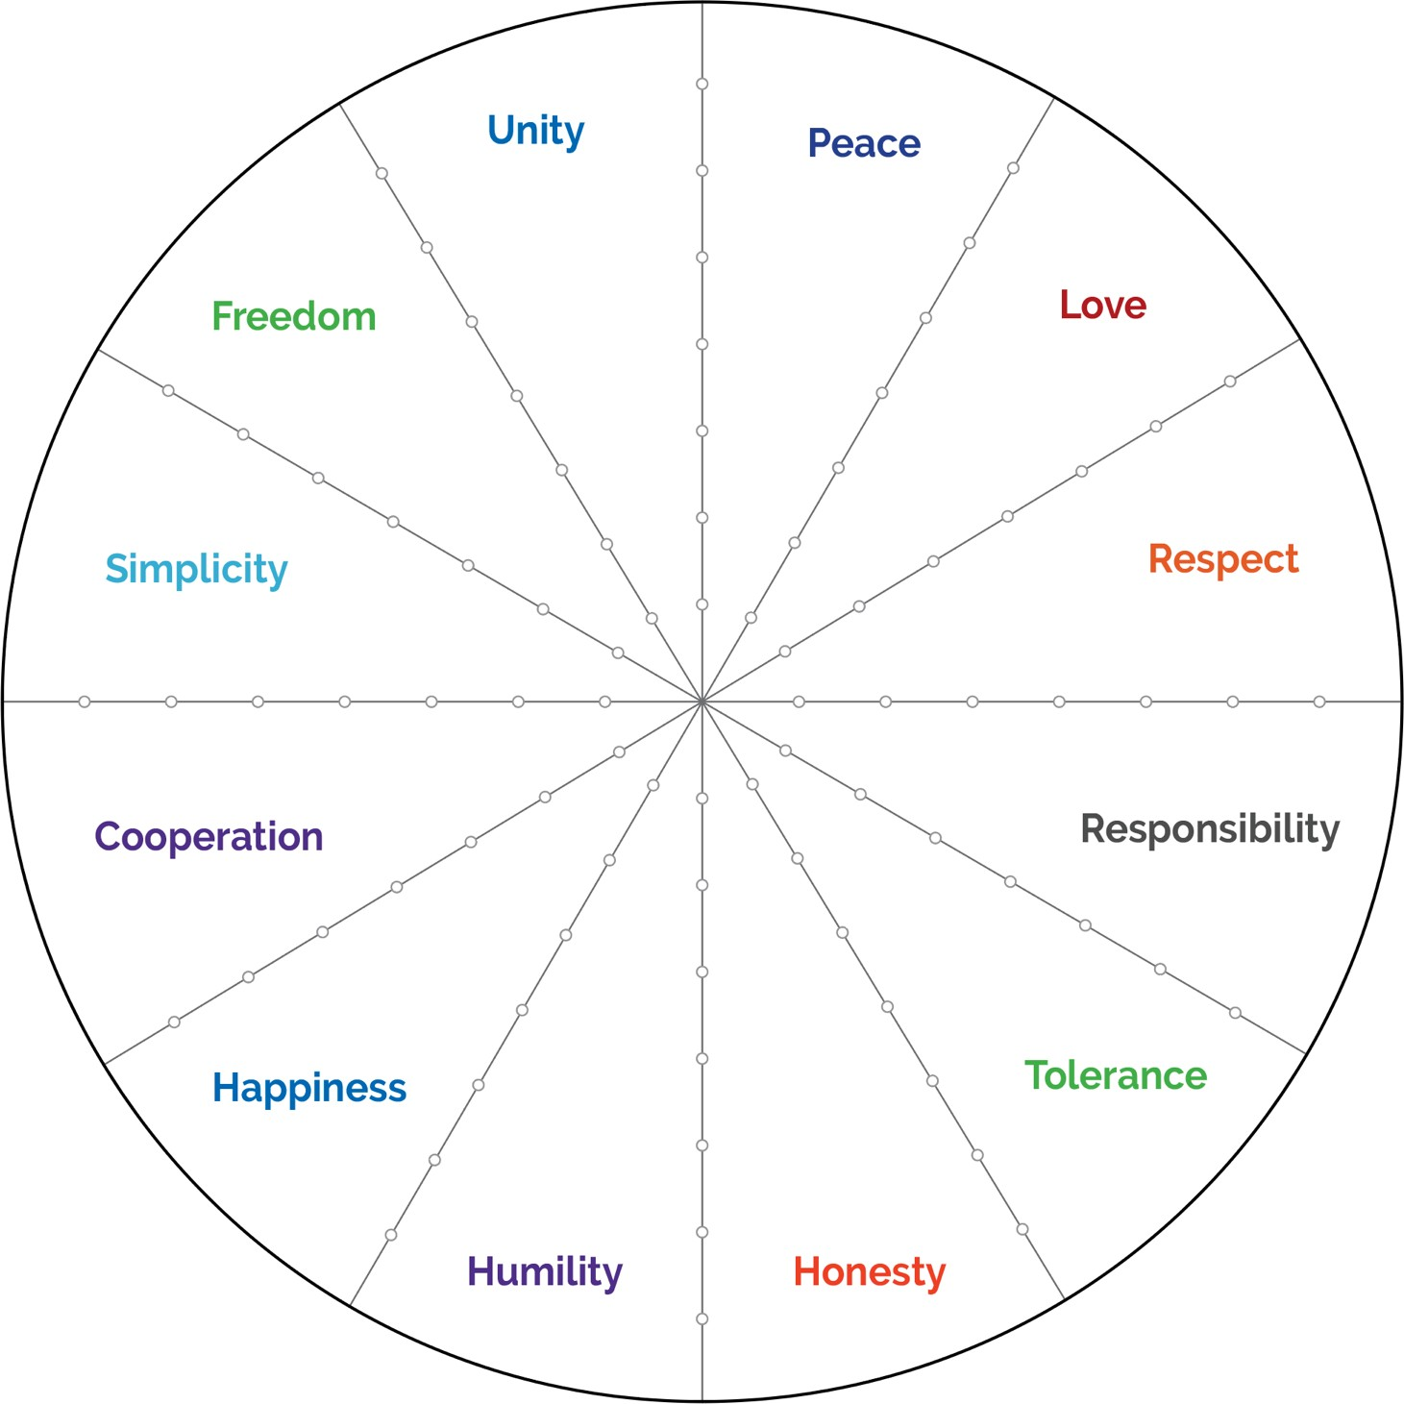
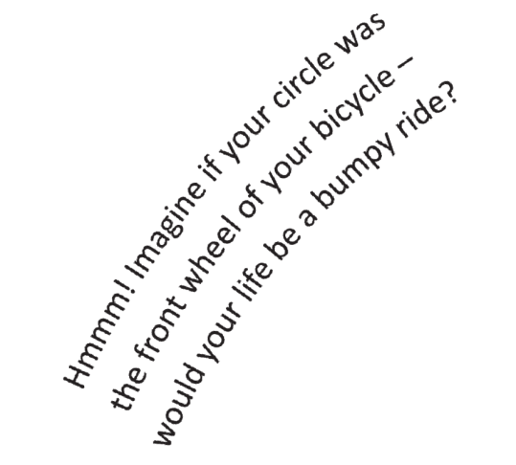
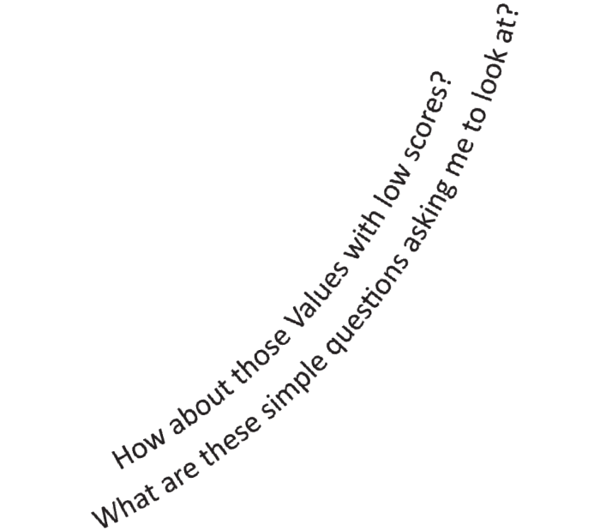

Would you like to go deeper? Values are about bringing your life into harmony and balance. You can further expand your Values Awareness by engaging in the full FREE ‘Living Values Education Self-Reflection’ 12-week Course. Send for Application distance@livingvalues.net More information is available from our website: www.livingvalues.net/distance

